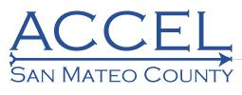
Adult Education
College and Career Educational Leadership

Agenda - Steering Committee Meeting
Thursday, January 16, 2020, 1:00 - 3:00 p.m.
San Mateo Adult School

12:30-1:00 Lunch

1:00 | I. Welcome, Introductions, and Agenda Review
1:05 | II. Community Pro - Reports Overview
1:25 | III. Website Status Update
1:35 | IV. Work Group - Roundtable: Reports and Updates  - Work Group 1 - Packaging of Support Services  - Work Group 2 - Curriculum Alignment Between Adult Schools, Colleges, and Training Partners  - Work Group 3 - Pathways: Short Term CTE Certificates and Training
2:00 | V. Work Group Sessions
2:45 | VI. Announcements and Next Steps
3:00 | Adjourn

