
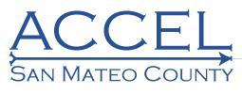


Steering Committee  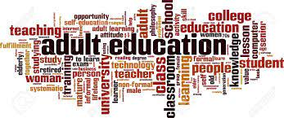 | MEETING MINUTES  Thursday, August 14, 2023  12:30 p.m. to 1:00 p.m. Lunch  1:00 p.m. to 2:00 p.m. Meeting  Location: San Mateo Adult & Career  Education  789 E. Poplar Avenue  San Mateo, CA

AGENDA TOPIC:
Welcome & Introductions

ACCEL Annual Plan  - ACCEL Accomplishments | Annual Plan Presentation by Dr. Ka’Ryn Holder-Jackson  PowerPoint Presentation  Annual Plan Overview  - Plans & Goals  - Regional Planning Overview  - Meeting Regional Needs  - Address Educational Needs  - Improve Integration of Services & Transitions  - Improve Effectiveness of Services  - Fiscal Management
ELL Healthcare Pathways Funding Opportunity | The California Community Colleges Chancellor's Office in partnership with the California Department of Education has announced their Letter of Intent for the English Language Learner Healthcare Pathways Grant  - The purpose of the Letter of Intent is to invite CAEP Consortia to participate in the ELL Health Care Pathways Initiative  - Management Team is reviewing the Grant
Strategic Action Teams Updates  - Marketing  - Data & Accountability | Marketing Team  - Team to focus on the development and review of marketing strategies and website  Data & Accountability Team  - Next meeting October 4, 2023
Announcements | San Mateo Adult & Career Education is hosting a Job Fair in partnership with JobTrain  Date: Friday, September 15, 2023  Time: 1:00 p.m. to 3:00 p.m.  Format: In-Person  Location: San Mateo Adult & Career Education
Public Comment | No public comments were brought forth
Adjourn | Next meeting on October 19, 2023

Attendees

Angulo, Nereida, Skyline College
Bourdon, Karla, South San Francisco Public Library, Project Read
Campos, Liliana, Sequoia Adult School
Efigenio, Araceli, San Mateo County Library
Feirman, Lawrence, Community Member
Feldman, Sarah, San Mateo County, Office of Community Affairs
Ford, Lauren, Skyline College
Gamet, Drew, La Costa Adult School
Garcia, Lynette, San Mateo Adult & Career Education
Holder-Jackson, Ka’Ryn, Executive Director
Kramer, Alex, College of San Mateo
Kravtsova, Marina, San Mateo Adult School
Mann, Kira, San Mateo Adult & Career Education
Ramirez, Janet, Cañada College
Risley, Carine, San Mateo County Library
Roganova, Tatiana, Sequoia Adult School
Sparks, Lisa, San Mateo Adult & Career Education
Taylor, Angela, San Mateo Adult & Career Education
Villar, Patty, San Mateo Adult & Career Education

